Croissants. . . . . .$6.00  Chicken Salad Croissant  Egg Salad Croissant  Tuna Salad Croissant  Egg, Ham and Cheese Croissant  Egg, Bacon and Cheese Croissant  Marble Rye Sandwiches.$7.00  Ham + Swiss  Italian  Roast Beef  Turkey  Salads  Chef Salad . . . . . .. $7.00  House Salad . . . . . .. $5.00  Grilled Chicken Salad . . . . . .. $7.50  Special Salad . . . . . .. $8.00  Spinach Salad . . . . . .. $7.00  Soups  Only $3.85  Monday: Creamy Cheddar Broccoli  Tuesday: Loaded Potato Bacon  Wednesday: Tomato Basil Bisque  Thursday: Hearty Chicken Noddle  Friday: Garden Vegetable Soup  Nancy’s Confections & Candy  Old-fashioned Candies & Fudges  Coffees  12 oz . . .$1.50 16 oz . . .$2.00  We carry a wide range of different blends and roasts. We also have coffee that is locally roasted by the Lake Gaston Coffee Co.  Iced Coffee  16 oz . . .. $2.00  Cappuccino  12 oz.. . $2.75 16 oz.. . $3.25  Caramel Coconut  Mocha Irish Cream  Vanilla Amaretto  White Chocolate Hazelnut and many more flavors  Expresso  2 oz Shot . . . . . $1.50  Latte  12 oz . . .. $2.75  Add a shot of flavor to your  coffee for just $0.50 | Paninis. . . .$8.00 - $9.00  Breakfast Egg + Prosciutto  Caprese  Grilled Cheese  Ham + Mozzarella  Pastrami  Pizza  Prosciutto + Pesto  Rueben  Roast Beef Chicken Ranch BLT  New Yorker The Club  BLT Veggie  Sides  Pasta Salad. . . . . . . . . . . .$3.25  Side House Salad. . . . . . .$2.50  Teas  12 oz hot . . . . 16 oz. cold  Apple Berry . . . . . . . $1.50  Herbal . . . . . . . $1.50  Herbal Eve . . . . . . . $1.50  Summer Sweet Tea . . . . . . . $1.00  Tangy Lemon Tea . . . . . . . $1.50  Unsweetened Tea . . . . . . . $1.00  Hidden Garden Chamomile . . . . . . . $1.75  Hidden Garden Earl Grey . . . . . . . $1.50  Hidden Garden English Breakfast . . . . . . . $1.50  Hidden Garden Green Tea . . . . . . . $1.50  Hidden Garden Mint . . . . . . . $1.50  Hidden Garden Peppermint . . . . . . . $1.75  Frappuccino  16oz . . . . . .. $3.50  Caramel Mocha Vanilla  White Chocolate Hazelnut Coconut Reeses Almond Joy  Hot Cocoa  12 oz. . . .$1.50 16 oz. . . .$2.00  Beverages  Bottled Water . . . . . .$1.00  Coke . . . . . . . . . . . . . $1.79  Diet Coke . . . . . . . . . .$1.79  Cherry Coke . . . . . . . $1.79  Vanilla Coke . . . . . .. $1.79  Sprite . . . . . . . . . . . . $1.79  Pibb Xtra . . . . . . . . . .$1.79  CheerWine . . . . . . . . . . . . . . . $1.60  Mistic Kiwi Strawberry, Lotta Colada, Mango Mania, Tropical Fruit, and Watermelon Kiwi. . . . . . .. $1.65  Red Rock Ginger Ale . . . . . .. $1.60  Stewart’s Black Cherry, Key Lime, Orange Cream, Grape, Cream Soda, and Root Beer. . . . . . . . .. $1.55  Gold Peak Sweet Tea, Unsweetened Tea, Green Tea, and Peach Tea. . . . . . . . . $1.99  Minute Maid Real Fruit Drinks: Orange, Apple and Orange-Pineapple. . . . . . $1.99  Sundrop. . . . . . . . . . . . . .$1.60 | Birdie’s Cheeses $6.95  Birdie’s Classic Pimento Cheese  Birdie’s Cream Cheese& Black Pepper Pimento  Birdie’s Garlic Parmesan Pimento  Birdie’s Jalapeño Pimento Cheese  Birdie’s Olive Pimento Cheese  Seasonal: Smoked Gouda & Roasted Red Pepper  Route 11 Chips $1.50  Bar-b-que  Dill Pickle  Lightly Salted  Sour Cream + Chives  Mama Zumas Revenge  Salt + Vinegar  Seasonal: Sweet Potato  Windmill Farms Baked Goods  Assorted doughnuts . . . . . . . $1.00  Eclairs . . . . . . . . . . . . . . . . . . . .$1.50  Morning Glory Muffins . . . . . . . $1.50  Lemon Poppy Seed Muffins . . . . . . . $1.50  Blueberry Muffins . . . . . . . $1.50  Chocolate Pie slice . . . . . . . $2.00  Coconut Pie Slice . . . . . . . $2.00  Chocolate Chip Cookie . . . . . . $.75 or 3 @$2.00  Monster Cookie . . . . . . . . . . . $.75 or 3 @ $2.00  Brownies . . . . . . . . . . . . . . . .$1.10 or 3 @ $3.00  Cheesecake, Carrot Cake or Hummingbird Cake by special order only  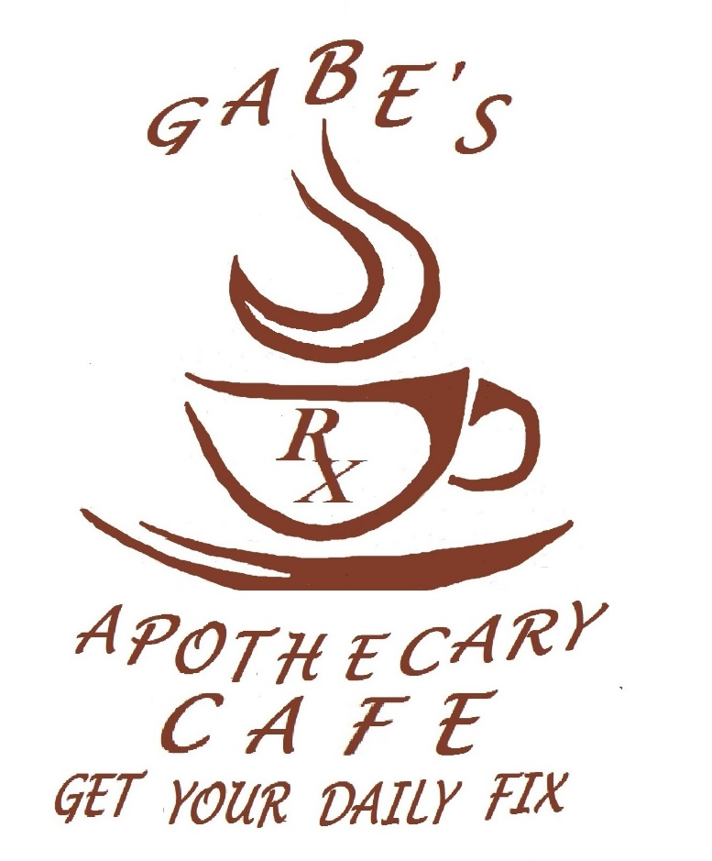  380 Washington Street  Boydton, VA 23917  (434)210-5082  Hours: 7:00 am – 5:00 pm  Monday thru Friday  Closed Saturday & Sunday We do cater on the weekends!  Catering Available for your special event, meetings or party!

